**PART A**

(Part A: TO BE REFFERED BY STUDENTS)

**Experiment No. 07**

**A.1 AIM:**

Implement basics of Angular JS by using directive, controller, expression, modules etc.

**A.2 Pre requisite:**

HTML, CSS, Javascript

**A.3 Outcome:**

After successful completion of this experiment students will be able to:

1. Understand and implement directives, expressions, controllers, scope in Angular JS.
2. Understand the principles behind data binding in Angular JS.

**A.4 Theory:**

Angular JS is an open source framework built on javascript

Directives are markers on a DOM element (such as an attribute, element name, comment or CSS class) that tell AngularJS's HTML compiler ($compile) to attach a specified behavior to that DOM element (e.g. via event listeners), or even to transform the DOM element and its children.

AngularJS comes with a set of these directives built-in, like ng-app, ngBind, ngModel, ngClass

Ex:

<body>

<h1>Sample Application</h1>

<div ng-app = "My App">

<p>Enter your Name: <input type = "text" ng-model = "name"></p>

<p>Hello <span ng-bind = "name"></span>!</p>

</div>

<script src = "https://ajax.googleapis.com/ajax/libs/angularjs/1.3.14/angular.min.js"></script>

</body>

Expressions:

Expressions are used to bind application data to html.

Expressions are written inside double braces like {{ expression}}.

Expressions behaves in same way as ng-bind directives

Controller

In AngularJS, a Controller is defined by a JavaScript constructor function that is used to augment the AngularJS Scope.

Controllers can be attached to the DOM in different ways. For each of them, AngularJS will instantiate a new Controller object, using the specified Controller's constructor function:

use the ng-controller directive. A new child scope will be created and made available as an injectable parameter to the Controller's constructor function as $scope.

<script>

var app = angular

.module("myModule", [])

.controller("myController", function($scope){

$scope.technologies = [

{"href": 'http://www.pngmart.com/files/4/Cute-Cartoon-PNG-Picture.png', likes: 0, dislikes:0}];

$scope.incrementLike = function(technology){

technology.likes++ ;

}

});

</script>

Data Binding in Angular JS works in MVC. Any changes to the view are immediately reflected in the model,and any changes in the model are propagated to the view.

AngularJS directives are used to extend HTML. They are special attributes starting with **ng**-prefix. Let us discuss the following directives −

* **ng-app** − This directive starts an AngularJS Application.
* **ng-init** − This directive initializes application data.
* **ng-model** − This directive defines the model that is variable to be used in AngularJS.
* **ng-repeat** − This directive repeats HTML elements for each item in a collection.

Example

**testAngularJS.htm**

<html>

<head>

<title>AngularJS Directives</title>

</head>

<body>

<h1>Sample Application</h1>

<div ng-app = "" ng-init = "countries = [{locale:'en-US',name:'United States'},

{locale:'en-GB',name:'United Kingdom'}, {locale:'en-FR',name:'France'}]">

<p>Enter your Name: <input type = "text" ng-model = "name"></p>

<p>Hello <span ng-bind = "name"></span>!</p>

<p>List of Countries with locale:</p>

<ol>

<li ng-repeat = "country in countries">

{{ 'Country: ' + country.name + ', Locale: ' + country.locale }}

</li>

</ol>

</div>

<script src = "https://ajax.googleapis.com/ajax/libs/angularjs/1.3.14/angular.min.js">

</script>

The following directives are used to bind application data to the attributes of HTML DOM elements –

**ng-disabled**

disables a given control.

**ng-show**

shows a given control.

**ng-hide**

hides a given control.

**ng-click**

represents a AngularJS click event.

Example

The following example shows use of all the above mentioned directives.

**testAngularJS.htm**

<html>

<head>

<title>AngularJS HTML DOM</title>

</head>

<body>

<h2>AngularJS Sample Application</h2>

<div ng-app = "">

<table border = "0">

<tr>

<td><input type = "checkbox" ng-model = "enableDisableButton">Disable Button</td>

<td><button ng-disabled = "enableDisableButton">Click Me!</button></td>

</tr>

<tr>

<td><input type = "checkbox" ng-model = "showHide1">Show Button</td>

<td><button ng-show = "showHide1">Click Me!</button></td>

</tr>

<tr>

<td><input type = "checkbox" ng-model = "showHide2">Hide Button</td>

<td><button ng-hide = "showHide2">Click Me!</button></td>

</tr>

<tr>

<td><p>Total click: {{ clickCounter }}</p></td>

<td><button ng-click = "clickCounter = clickCounter + 1">Click Me!</button></td>

</tr>

</table>

</div>

<script src = "https://ajax.googleapis.com/ajax/libs/angularjs/1.3.14/angular.min.js">

</script>

</body>

**A.5 Procedure/Task:**

1 Develop Angular JS program that allows user to input their first name and last name and display their full name. Note: The default values for first name and last name may be included in the program .

2 Develop a simple Angular JS calculator application that can perform basic mathematical operations (addition, subtraction, multiplication, division) based on user input .

3. Write an Angular JS application that can calculate factorial and compute square based on given user input.

4. Develop AngularJS application that displays a detail of students and their CGPA. Allow users to read the number of students and display the count. Note: Student details may be included in the program.

5. Write an AngularJS script to print details of bank (bank name, MICR code, IFC code, address etc.) in tabular form using ng-repeat

3. Prepare the document. Save and close the file and name it as **EXP07_Name of Student**

**PART B**

(PART B: TO BE COMPLETED BY STUDENTS)

(Students must submit the soft copy as per following segments within two hours of the practical. The soft copy must be uploaded on the Blackboard or emailed to the concerned lab in charge faculties at the end of the practical in case the there is no Black board access available)

|  |  |
| --- | --- |
| Roll No. : C035 | Name: Sukhada Gulhane |
| Class : B | Batch : B2 |
| Date of Experiment : | Date/Time of Submission : |
| Grade : |  |

**B.1 Code:** *(Paste your Code here)*

***Task 1:***

<!DOCTYPE *html*>

<html *lang*="en">

<head>

    <meta *charset*="UTF-8">

    <meta *name*="viewport" *content*="width=device-width, initial-scale=1.0">

    <title>AngularJS Full Name Display</title>

    <script *src*="https://ajax.googleapis.com/ajax/libs/angularjs/1.8.2/angular.min.js"></script>

    <style>

        body {

            font-family: Arial, sans-serif;

            margin: 50px;

            text-align: center;

        }

        input {

            padding: 5px;

            margin: 10px;

        }

    </style>

</head>

<body *ng-app*="">

    <h2>AngularJS Full Name Display</h2>

    First Name:<input *type*="text" *ng-model*="firstName">

    <br>

    Last Name: <input *type*="text" *ng-model*="lastName">

    <h3>Full Name: {{ firstName + '' + lastName }}</h3>

</body>

</html>

***Task 2:***

<!DOCTYPE *html*>

<html *lang*="en">

<head>

    <meta *charset*="UTF-8">

    <meta *name*="viewport" *content*="width=device-width, initial-scale=1.0">

    <title>AngularJS Calculator</title>

    <script *src*="https://ajax.googleapis.com/ajax/libs/angularjs/1.8.2/angular.min.js"></script>

</head>

<body *ng-app*="calculatorApp" *ng-controller*="calculatorController">

    <h2>AngularJS Calculator</h2>

    <label>First Number:</label>

    <input *type*="number" *ng-model*="num1"><br><br>

    <label>Second Number:</label>

    <input *type*="number" *ng-model*="num2"><br><br>

    <button *ng-click*="result = num1 + num2">Addition (+)</button>

    <button *ng-click*="result = num1 - num2">Subtraction (-)</button>

    <button *ng-click*="result = num1 * num2">Multiplication (*)</button>

    <button *ng-click*="result = num1 / num2">Division (/)</button>

    <h3>Result: {{ result }}</h3>

    <script>

        varapp= *angular.module*("calculatorApp",[]);

*app.controller*("calculatorController", function($scope) {

*$scope.*num1 = 0;

*$scope.*num2 = 0;

*$scope.*result = 0;

        });

    </script>

</body>

</html>

***Task 3:***

<!DOCTYPE *html*>

<html *lang*="en">

<head>

    <meta *charset*="UTF-8">

    <meta *name*="viewport" *content*="width=device-width, initial-scale=1.0">

    <script *src*="https://ajax.googleapis.com/ajax/libs/angularjs/1.8.2/angular.min.js"></script>

    <title>Factorial & Square Calculator</title>

</head>

<body *ng-app*="calculatorApp" *ng-controller*="calculatorController">

    <h2>Factorial & Square Calculator</h2>

    Enter a number: <input *type*="number" *ng-model*="number"><br><br>

    <button *ng-click*="calculateFactorial()">Calculate Factorial</button>

    <button *ng-click*="calculateSquare()">Calculate Square</button>

    <h3>Factorial: {{ factorialResult }}</h3>

    <h3>Square: {{ squareResult }}</h3>

    <script>

        varapp= *angular.module*("calculatorApp",[]);

*app.controller*("calculatorController", function($scope) {

*$scope.calculateFactorial* = function() {

                letnum= *$scope.number*;

                if (num < 0) {

*$scope.*factorialResult = "Not Defined";

                } else {

                    letfact=1;

*for* (leti=1; i <= num; i++) {

                        fact *= i;

                    }

*$scope.*factorialResult = fact;

                }

            };

*$scope.calculateSquare* = function() {

*$scope.*squareResult = *$scope.*number * *$scope.*number;

            };

        });

    </script>

</body>

</html>

***Task 4:***

<!DOCTYPE *html*>

<html *lang*="en">

<head>

    <meta *charset*="UTF-8">

    <meta *name*="viewport" *content*="width=device-width, initial-scale=1.0">

    <script *src*="https://ajax.googleapis.com/ajax/libs/angularjs/1.8.2/angular.min.js"></script>

    <title>Student Details & CGPA</title>

</head>

<body *ng-app*="studentApp" *ng-controller*="studentController">

    <h2>Student Details & CGPA</h2>

    <table border="1">

        <tr>

            <th>Name</th>

            <th>CGPA</th>

        </tr>

        <tr *ng-repeat*="student in students">

            <td>{{ student.name }}</td>

            <td>{{ student.cgpa }}</td>

        </tr>

    </table>

    <h3>Total Number of Students: {{ students.length }}</h3>

    <script>

        varapp= *angular.module*("studentApp",[]);

*app.controller*("studentController", function($scope) {

*$scope.*students = [

                { name: "Sukhada", cgpa: 8.9 },

                { name: "Ashmit", cgpa: 9.5 },

                { name: "Tanay", cgpa: 9.2 },

                { name: "Neeral", cgpa: 8.1 }

            ];

        });

    </script>

</body>

</html>

***Task 5:***

<!DOCTYPE *html*>

<html *lang*="en">

<head>

    <meta *charset*="UTF-8">

    <meta *name*="viewport" *content*="width=device-width, initial-scale=1.0">

    <script *src*="https://ajax.googleapis.com/ajax/libs/angularjs/1.8.2/angular.min.js"></script>

    <title>Bank Details</title>

</head>

<body *ng-app*="bankApp" *ng-controller*="bankController">

    <h2>Bank Details</h2>

    <table border="1">

        <tr>

            <th>Bank Name</th>

            <th>MICR Code</th>

            <th>IFSC Code</th>

            <th>Address</th>

        </tr>

        <tr *ng-repeat*="bank in banks">

            <td>{{ bank.name }}</td>

            <td>{{ bank.micr }}</td>

            <td>{{ bank.ifsc }}</td>

            <td>{{ bank.address }}</td>

        </tr>

    </table>

    <h3>Total Banks: {{ banks.length }}</h3>

    <script>

        varapp= *angular.module*("bankApp",[]);

*app.controller*("bankController", function($scope) {

*$scope.*banks = [

                { name: "State Bank of India", micr: "400002032", ifsc: "SBIN0001234", address: "Mumbai, India" },

                { name: "HDFC Bank", micr: "400240003", ifsc: "HDFC0005678", address: "Pune, India" },

                { name: "ICICI Bank", micr: "110229003", ifsc: "ICIC0002345", address: "Delhi, India" },

                { name: "Axis Bank", micr: "600002015", ifsc: "AXIS0007890", address: "Chennai, India" }

            ];

        });

    </script>

</body>

</html>

**B.2 Output**

*(Take screen shots of the output at run time and paste it here)*

***Task 1:.***

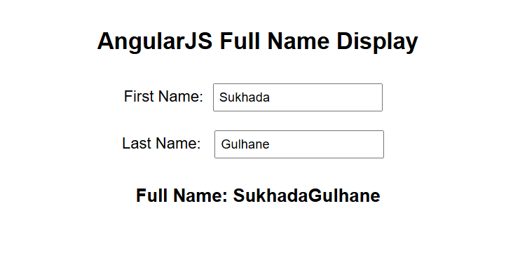

***Task 2:***

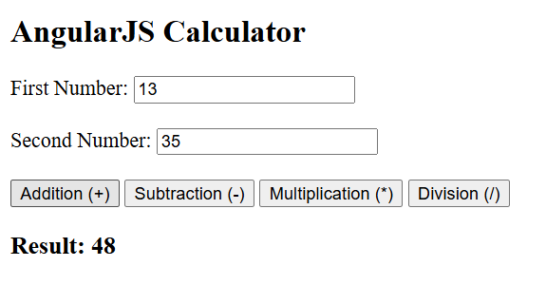

***Task 3:***

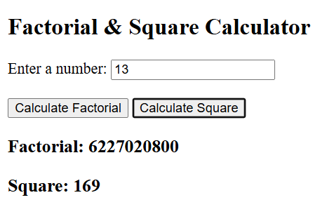

***Task 4:***

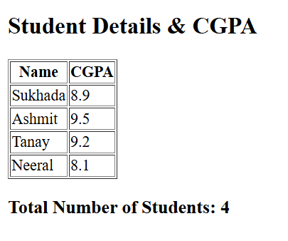

***Task 5:***

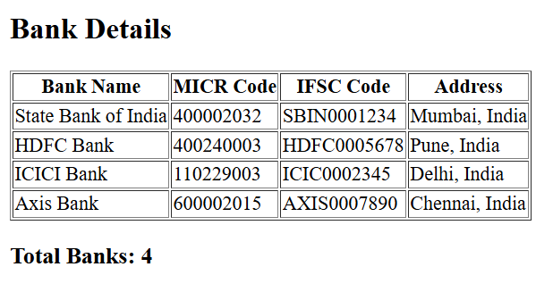

**B.3 Conclusion:**

*(Students must write the conclusion as per the attainment of individual outcome listed above)*

Through this practical, we successfully implemented various AngularJS functionalities, including dynamic data binding, event handling, and the use of directives like ng-repeat. This helped us understand how AngularJS can be used to create interactive web applications efficiently.

**B.3 Observations and Learning:**

*(Students must write their observations and learnings as per the attainment of individual outcome listed above)*

• Learned how to create an **AngularJS module and controller**.

• Understood the use of **ng-repeat** for dynamically displaying lists.

• Explored how to bind user inputs and handle events.

• Gained experience in creating **responsive tables** and working with structured data.

• Observed how AngularJS simplifies **DOM manipulation and data binding** compared to plain JavaScript.